**Matrimonial App**

**ER-Diagram**

**1.What is ER-Diagram?**

* An Entity Relationship (ER) Diagram is a type of flowchart that illustrates how “entities” such as people, objects or concepts relate to each other within a system.
* It develops a conceptual design for the database. It also develops a very simple and easy to design view of data.
* In other words, ER diagrams help to explain the logical structure of databases.
* ER-Diagram is a pictorial representation of data that describes how data is communicated and related to each other.

**2.Why we use ER-Diagram?**

* Provide a preview of how all your tables should connect, what fields are going to be on each table.

* Helps to describe entities, attributes, relationships.
* ER diagrams are translatable into relational tables which allows you to build databases quickly.
* ER diagrams can be used by database designers as a blueprint for implementing data in specific software applications

**3.Components of an ER-Diagram**

The key components of an ER-Diagram include entities, attributes, relationships, and cardinality.

**3.1. Entities**

Entities represent real-world objects or concepts in a database. They can be tangible things like a person, place, or thing, or intangible concepts like an event or an idea. In an ER-Diagram, entities are depicted as rectangles or boxes, and their names are written inside them. Each entity typically corresponds to a table in a relational database.

**3.2. Attributes**

Attributes are the characteristics or properties of an entity. They provide additional information about the entity and define the data that can be stored in the corresponding table. Attributes are depicted as ovals or ellipses connected to the entity they belong to. Each attribute has a name that describes its purpose.

**3.3 Relationships**

Relationships describe the associations between entities. They represent how entities are connected or linked to each other. Relationships are depicted as diamond shapes and are labelled with verbs or phrases that describe the nature of the relationship. Relationships can be one-to-one, one-to-many, or many-to-many, depending on how the entities are related.

**3.4 Cardinality**

Cardinality defines the numerical constraints on the participation of entities in a relationship. It specifies the minimum and maximum number of occurrences of one entity that can be associated with a single occurrence of the other entity. Cardinality is represented using notations like "1" (one occurrence), "0..1" (zero or one occurrence), "0.." (zero or more occurrences), or "1.." (one or more occurrences).

**ER-Diagram**

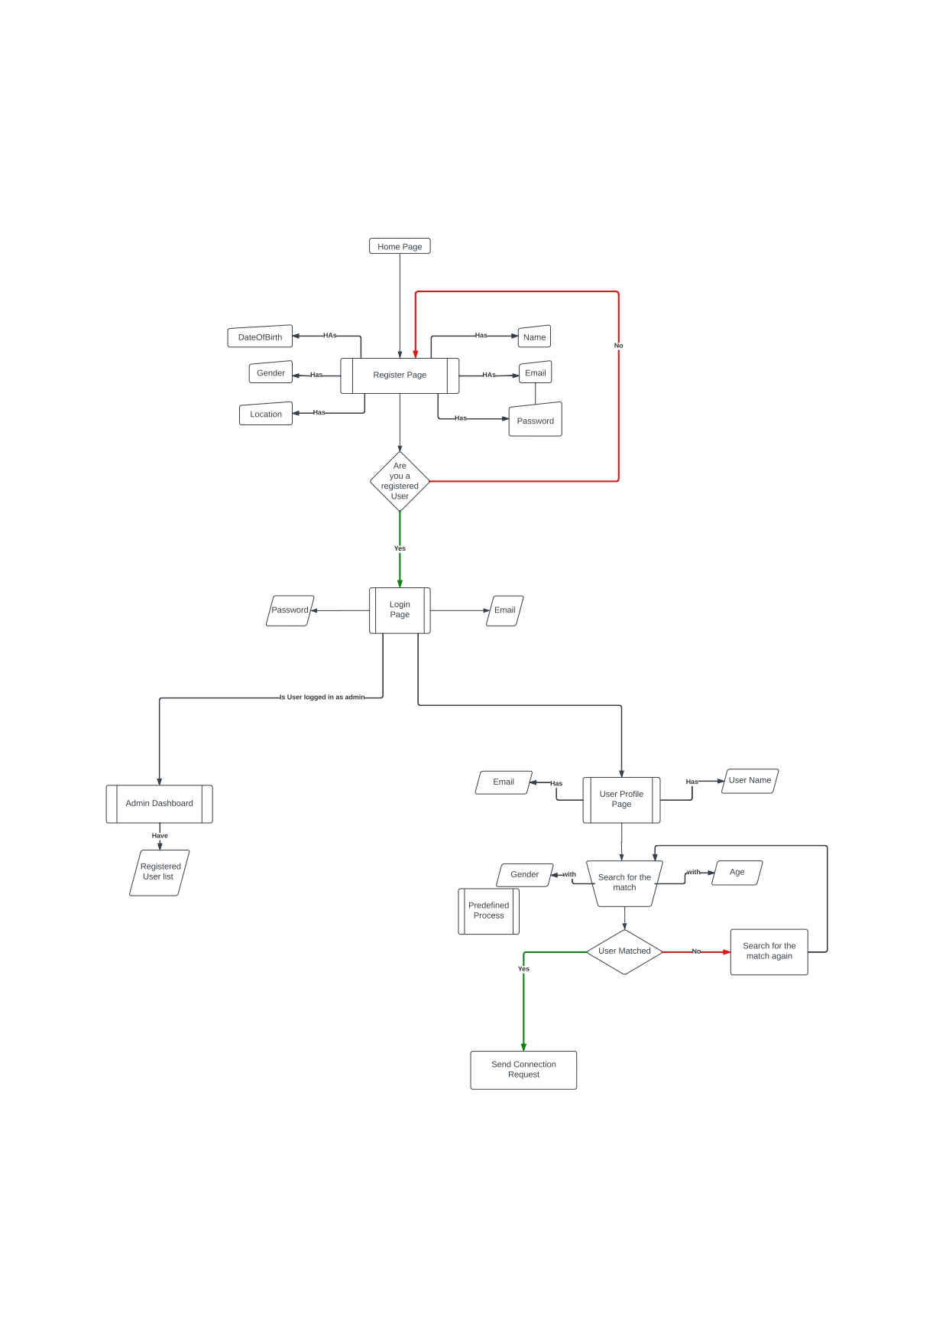

The above ER-Diagram represents Matrimony app. In this app user can register with all details and select one partner for marriage.

HomePage is the main attribute in the ER-Diagram. In this homepage we found some options like Registration, Login, Profile, Admin Dashboard, Chat. By opening this website user can register with Name, Email, DateofBirth, Gender, password, location. After registration user can login with the email and password. Without registration you don’t login to this website. After completion of login process, you can go to profile section and give your username and email then go to search for the match by giving your gender and age, after that you find someone has matching to you then send connection request, Otherwise you can go back to search for the match. By clicking on Admin Dashboard you see the registered user list.